1.Analysis, Development and Verification of 8-bit and 16-bit Arithmetic
Operations Using Assembly Language Program
OBJECTIVES:- (CO1, BL4, WK3)
● To develop and execute assembly language programs to perform 8-bit
and 16-bit addition and subtraction of numbers stored in memory.
● To develop and execute assembly language programs to perform 8-bit
and 16-bit multiplication and division using the AX and DX:AX
registers.
● To analyze the carry, borrow, auxiliary-carry, parity, zero, sign and
overflow flags produced by each arithmetic operation.
● To verify the register and memory results against manual
hexadecimal calculations and interpret the immediate, register and
memory addressing modes used.
OUTPUT:
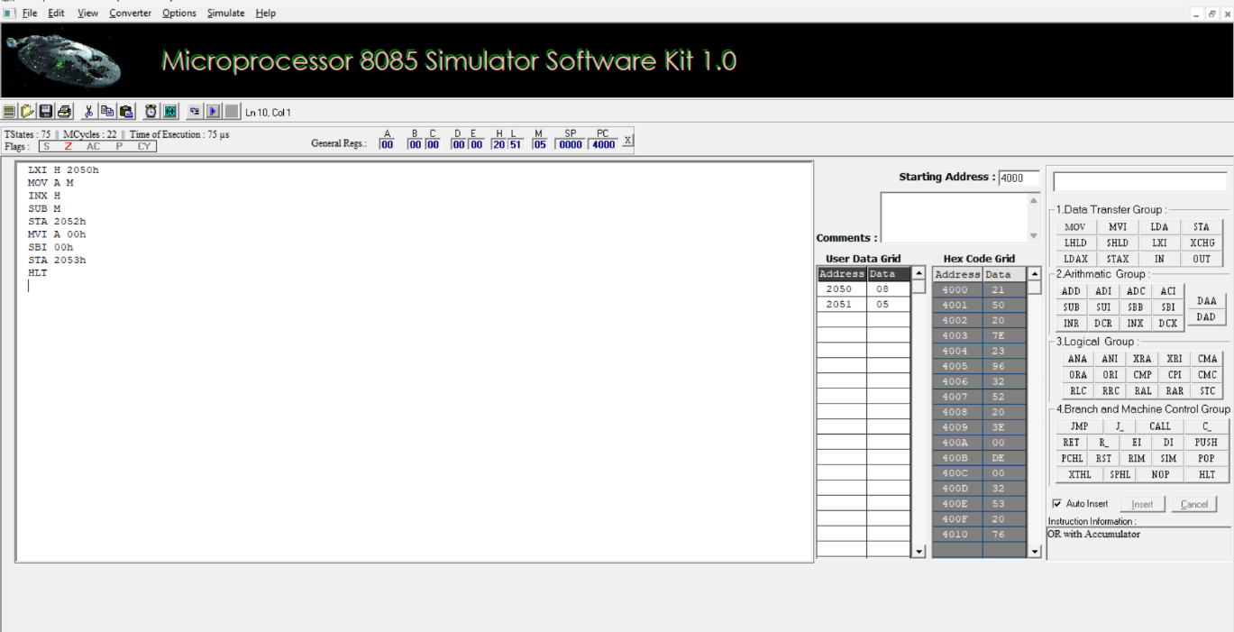
Fig 1 : 8 bit Addition
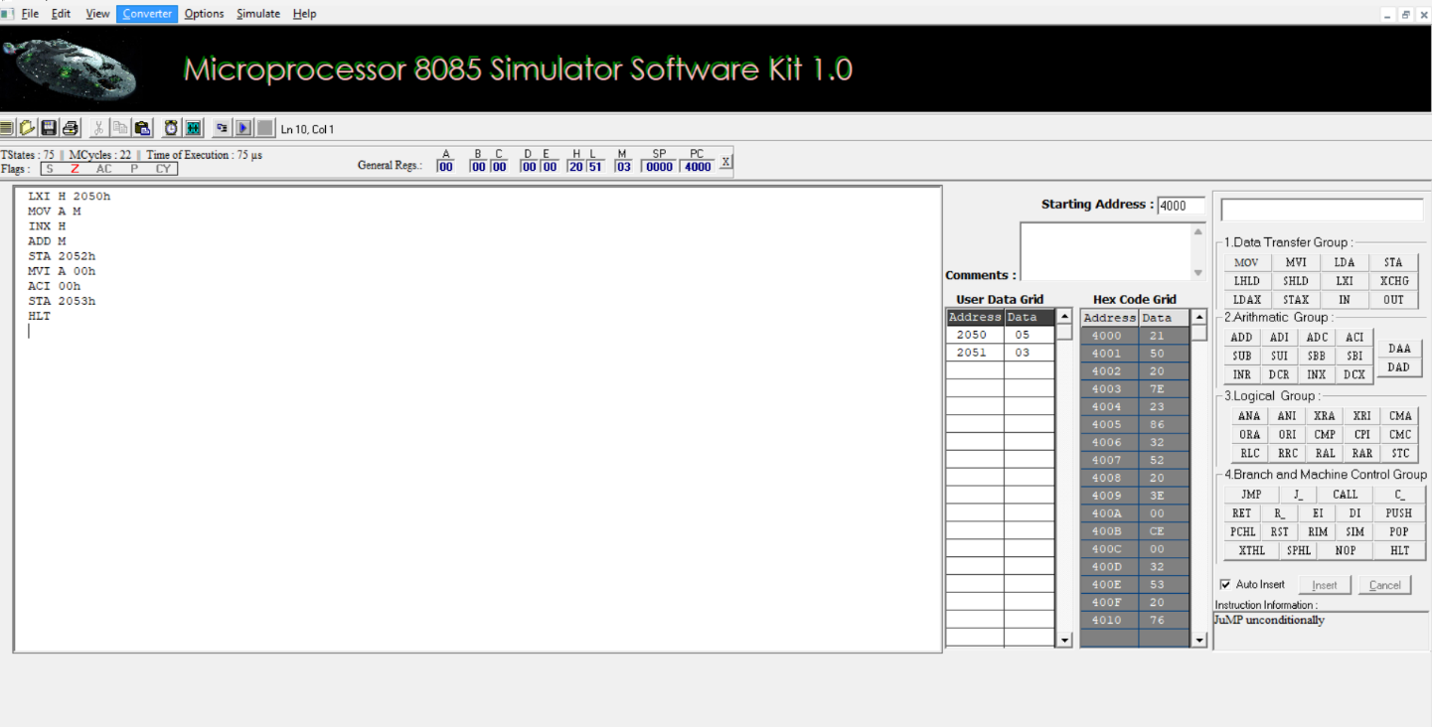
Fig 2 : 8 bit Subtraction
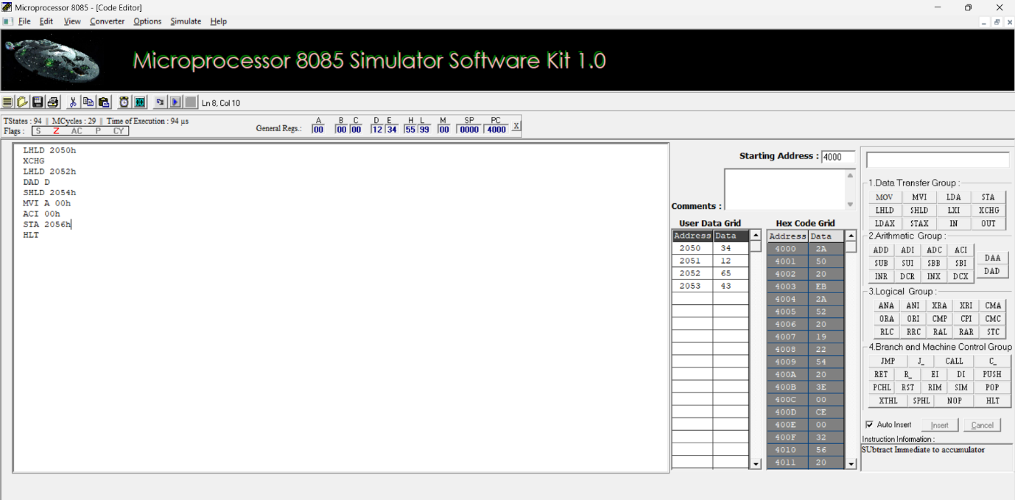
Fig 3: 16 bit Addition
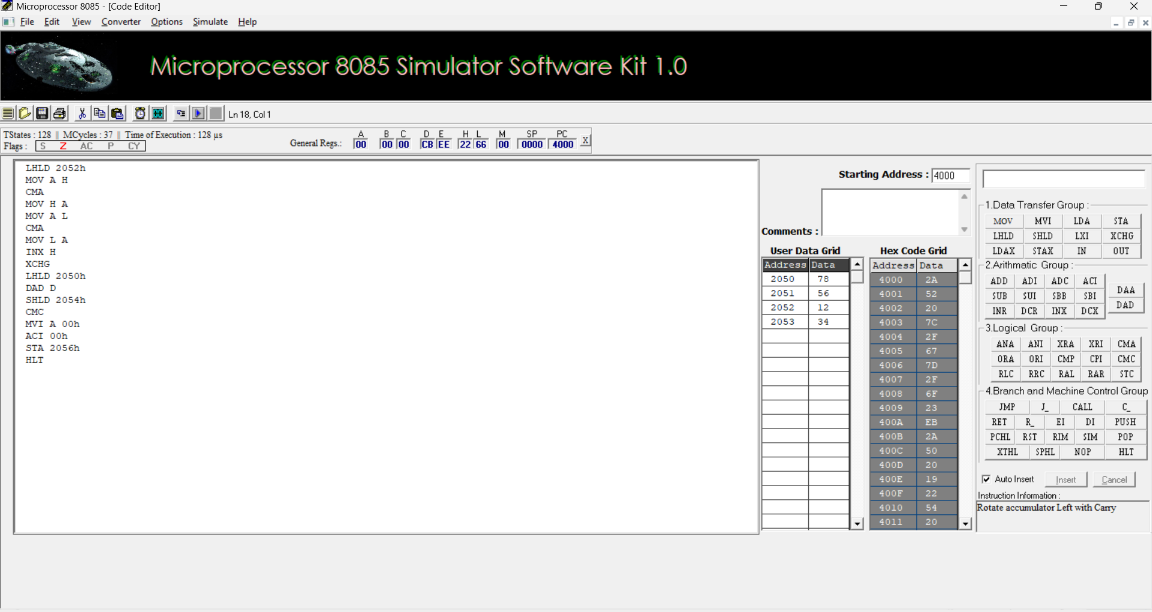
Fig 4 : 16 bit Subtraction
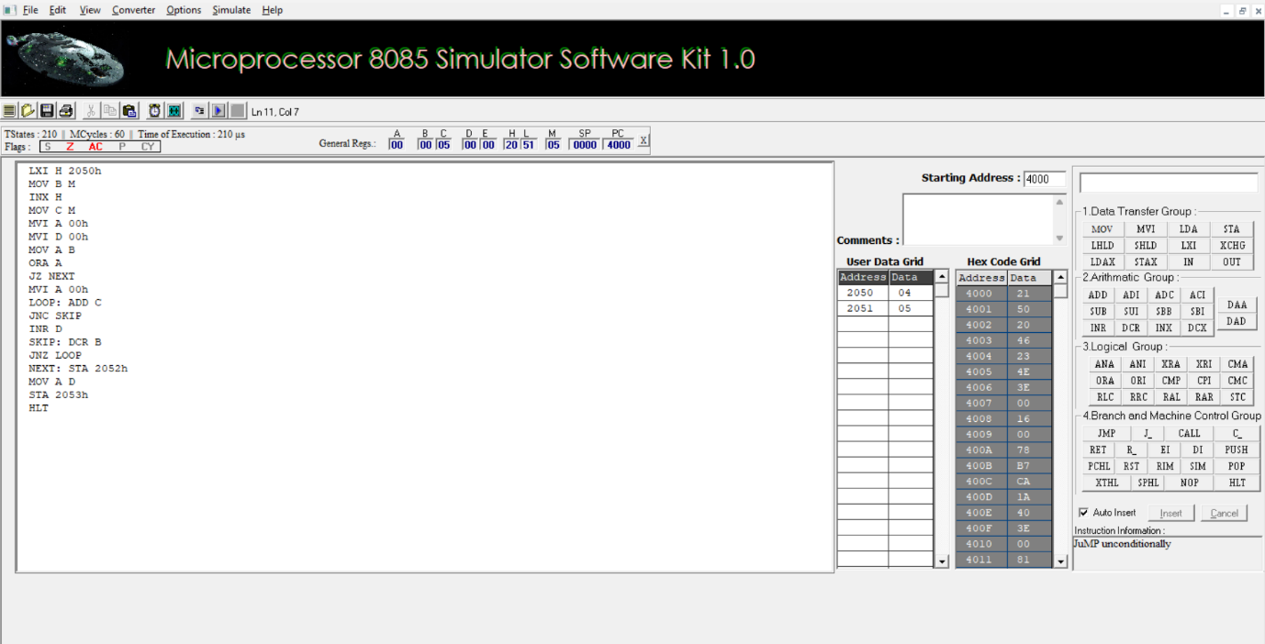
Fig 5: 8 bit Multiplication
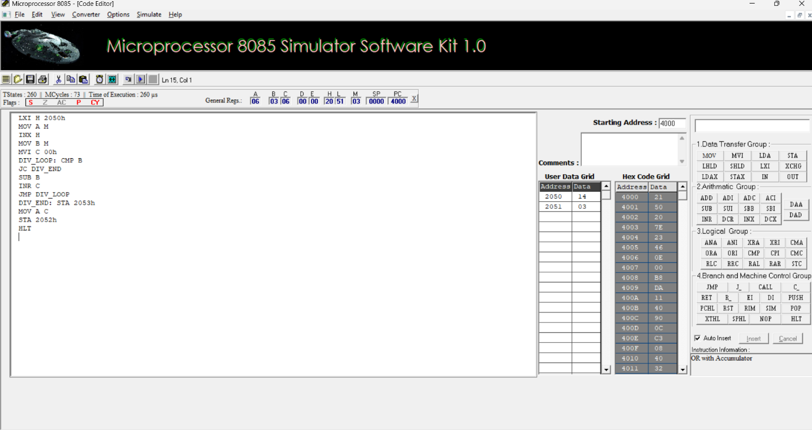
Fig 6: 8 bit Division
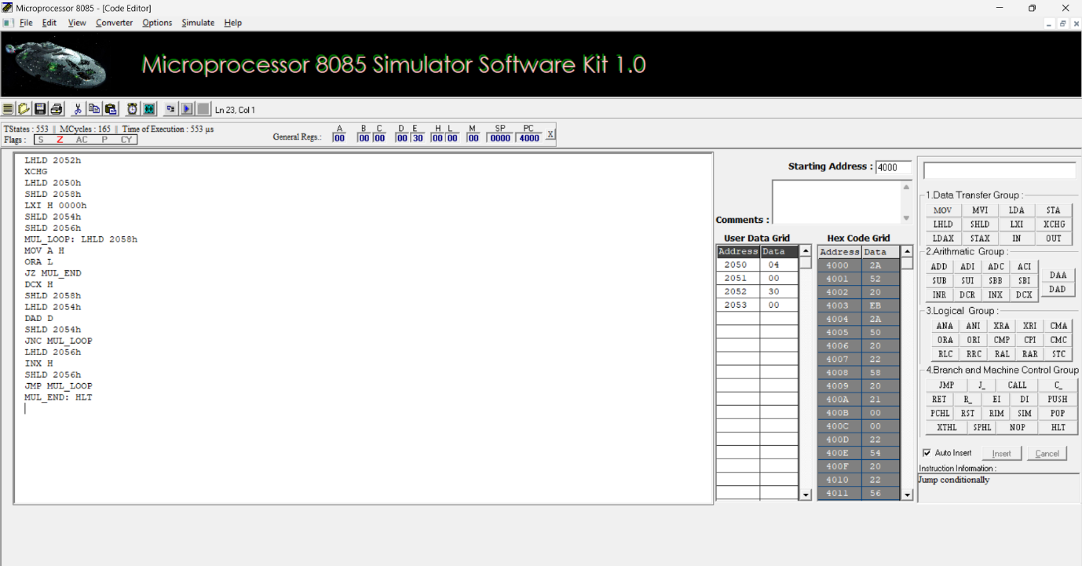
Fig 7: 16 bit Multiplication
RESULT : Successfully coded, assembled, and executed 8-bit and 16-bit arithmetic operations (Addition, Subtraction, Multiplication, and Division) on the 8085 simulator. Verified that all input data, intermediate steps, and final results accurately matched manual hexadecimal calculations and memory mappings.
REFLECTION : These laboratory experiments provided a comprehensive demonstration of 8085 microprocessor architecture and low-level assembly programming. Implementing complex multi-byte arithmetic operations—such as multiplication and division—using only primitive instructions highlighted the operational mechanics and constraints of the Arithmetic Logic Unit (ALU). Real-time monitoring of status flags, memory addresses, and register states effectively bridged theoretical concepts with practical execution.

